Rapid Cross-Plot Discrimination of Commercial Potash Mineralization – Case Histories
Donald. G. Hill, PhD.
E. R. (Ross) Crain, P.Eng.
Presented by Don Hill at SPWLA 62nd Annual Symposium, May 2021,
virtually via MP4 video of narrated PowerPoint slideshow. Full text published in SPWLA 2021 Symposium Transactions. This is the pre-publication version.

Abstract
Potash minerals are a source of potassium, which is used for the manufacture of gunpowder and fertilizer. Commercial potash mineralization is often discovered when petroleum wells are drilled through evaporite sequences and the gamma ray log “goes off scale”. This is because potassium is one of the naturally occurring radioactive elements, emitting gamma rays from the ⁴⁰K isotope, in its decay to ⁴⁰Ar.
However, not all potash minerals may be commercial sources of potassium via underground mechanical or solution mining techniques and potassium is not the only radioactive element. For example, the mineralogy of the McNutt “Potash” member of the Salado Formation in SE New Mexico, is extremely complex, consisting of multiple thin (i.e., less than 10 ft thick) beds of six low-grade (radioactive) potash minerals, only two of which are commercial. There are also four non-radioactive evaporite minerals, one of which interferes with potash milling chemistry, and numerous claystones and marker beds (shales), with GR count rates comparable to the low-grade potash.
Because of this complexity, traditional wireline and logging while drilling potash assay techniques, such as gamma ray log-to-core assay transforms, may not be sufficient to identify potentially commercial potash mineralization, for underground mining. Crain, Anderson and Hill developed linear programming, and multi-mineral analyses, respectively, to estimate potash mineralogy and grades. However, both of these approaches require complete sets of multiple log measurements.
In SE New Mexico, petroleum wells are drilled through the McNutt “Potash” member of the Salado Formation, with air, cased and drilled out to TD in the underlying sediments, with water based mud. Complete log suites are then run from TD to the casing shoe, with only the GR and neutron logs recorded through the cased evaporite sequence for stratigraphic and structural correlation.
As a result, numerous oil and gas wells, in SE New Mexico, have cased whole gamma ray and neutron logs, through the Salado Evaporite. Logs, from these wells could provide a rapid potash screening database, if used properly.
A simple screening cross-plot technique, the Potash Identification (PID) plot, utilizing only gamma ray and neutron porosity, is proposed and successfully demonstrated, as a potential screening tool. This technique can be used with both open and cased-hole petroleum well logs, as well as core hole wire-line logs, and provides discrimination of commercial potash mineralization from non-commercial (potash and non-potash) radioactive mineralization.
Case histories of the use of PID cross plots in the evaporite basins of Michigan, Nova Scotia, Saskatchewan, and SE New Mexico are described. The technique may also be useful in screening potential potash deposits in China, Europe, North Africa, and South America.
Introduction
Potassium is the 7th most common element in the earth’s crust. It is a common component in both commercial and non-commercial minerals. It is economically important as a food preservative and seasoning, as well as a major component in gunpowder and fertilizer.
Metallic potassium is highly reactive. Like sodium metal, potassium metal will spontaneously combust if exposed to air. Because of this, it does not exist in the native state. The most common
Simple high grade potassium minerals are evaporites.
Potassium 40 (⁴⁰K) is radioactive and decays to argon 40 (⁴⁰A), which is a stable isotope. The potassium-argon age dating technique as been used to date igneous & volcanic rocks as old as 4,500,000,000 years and as young as 20,000 years. Commercial potash deposits are often discovered when GR curves in wells drilled through evaporites “Go Off Scale”.

Potash and US Potash History
There is no Potash (K₂O) mineral. The term “Potash” traces its origin to North American colonial times when “Potash”, used in manufacture of gunpowder, was one of the first colonial exports. The process to manufacture potash included the following steps:
- Hardwood timber was burned.
- The ashes were leached.
- The resulting black powder (the “Pot Ash”, or K₂CO₃) was refined to K₂O and used to manufacture gunpowder, first in the mother country, and later in the colonies.
The current use of the term, “Potash” (K₂O) is one of convenience for commodity transactions. As a result, all naturally occurring “Potash Minerals” have been assigned “Equivalent Potash (K₂O) values.
In spite of its North American history, prior to WW-I, most of the potash used in the US for gunpowder and fertilizer, was imported from mines in Eastern Europe. Blockades of German ports, during WW-I, denied US access to these Eastern European potash supplies and resulted in potash shortages. As a result, the US government declared “Potash” to be a “Strategic Mineral”, and provided for the establishment of “Potash Enclaves” wherever commercial US potash deposits were discovered. Modest potash deposits were discovered, between WW-I and WW-II, in SE NM, the Paradox Basin of Eastern Utah, and later, deep deposits, in the Michigan Basin, as the result of oil and gas well drilling.
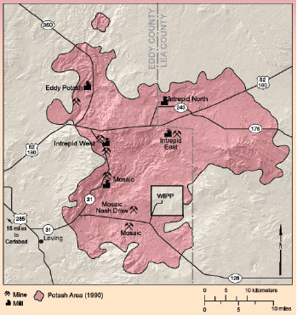
Figure 1. SE New Mexico Potash Enclave and WIPP (after: Barker and Austin, 1993).
The 1940’s discovery of the Prairie Evaporite Potash Deposits, in Saskatchewan, eclipsed all US Potash operations, combined, and changed the economics of the US Potash mining industry, making the US Potash Enclaves, superfluous. However, the US Potash Enclaves still exist.
SE New Mexico Potash Area/Enclave
Low-grade potash was discovered in SE New Mexico oil well cores, in 1925. The US Secretary of the interior created the SE NM Potash Area/Enclave, in 1931 (see Figure 1). The purpose of this order was to preserve this Strategic mineral resource, for future development. In spite of the Prairie Evaporite Potash Deposits, this Enclave still exists.
In 1973, the US Atomic Energy Commission (AEC, now Department of Energy, DOE) condemned a 16 square mile area within the New Mexico Potash Enclave, as a Waste Isolation Project Pilot Project (WIPP), for storage of radioactive waste. As part of this action, the AEC drilled, cored and logged, with complete sets of commercial and USGS wireline measurements, 21 coreholes.

SE New Mexico Potash Area Oil/Gas Well Drilling, Logging & Casing Protocols
Most SE New Mexico oil and gas reservoirs are below the Salado evaporites, which include the 11 potash zones of the McNutt Member. Over time the typical petroleum well drilling, logging, & casing programs have developed to:
- Air drilling through the Salado evaporites.
- Cased and cemented to the surface, without logging.
- Drilled to TD, using water based muds.
- Complete set of FE logs run from TD to the surface casing shoe.
- GR and neutron only, run through the cased interval.
As a result, the only evaporite wireline measurements available from most SE NM petroleum wells will be cased hole GR and neutron logs.
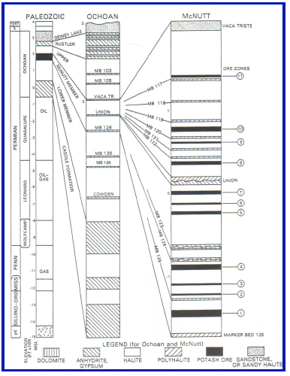
Figure 2. Regional Stratigraphic Column for the SE NM Potash Area (after: Griswold, 1982).

SE New Mexico McNutt Member Salado Formation Lithology and Mineralogy
The SE NM potash resources are confined to the McNutt Member of the Salado Formation of the Ochoan evaporites. Figure 2 shows the regional Stratigraphic Column of the SE NM Potash Area, with expanded Sections of the Ochoan evaporites, and the McNutt Member of the Salado Formation. Along with the 11 potash ore zones and associated USGS regional marker (most probably ash) beds. For example, the 11th Potash Ore Zone is located between USGS marker beds 119 & 120. Potash salts are among the last to precipitate from a bittern. As a result, not every “Ore Zone” contains commercial potash, at every location.

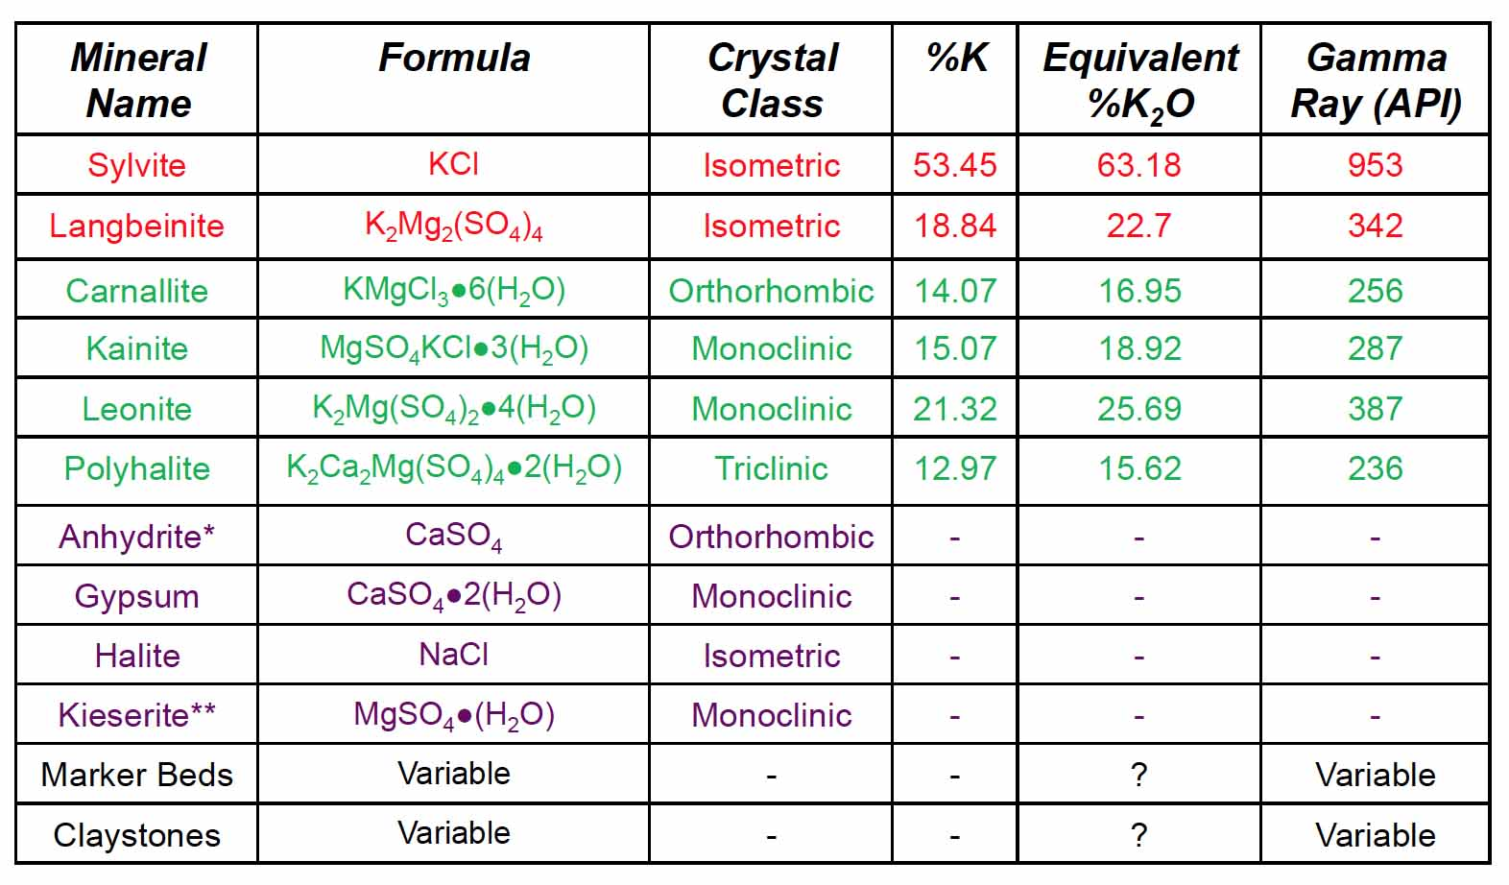
Table 1. SE New Mexico McNutt Member, Salado Formation Major Rocks & Minerals.
Table 1 summarizes the major rocks and minerals of the SE NM McNutt member of the Salado Formation. Those entries in red are the commercial potash minerals. The minerals in red are the commercial potash minerals. The minerals in green are the potash minerals that are not considered commercial, for underground mining. Those minerals in violet are the non-potash evaporite minerals. Finally the non-evaporite rocks, which are often radioactive, are in black. While there are six potash minerals in the McNutt Member, only two of them are considered to be commercial for underground mining.

SE New Mexico Potash Commercial Standards
At the time of the current study, commercial Potash reserves standards were in flux. However, based upon a 1986 Secretary of the Interior Order, the following standards were generally accepted:
- At least one bed of ≥ 4 ft thickness with,
- Sylvite and/or langbenite grade ≥ 4% concentration.

Initial wireline Analysis Validation Attempt
Ignoring the variable gamma ray responses of the marker beds and the claystones, plotting the pure mineral GR vs. equivalent %K₂O yields the linear relationship of Figure 3.
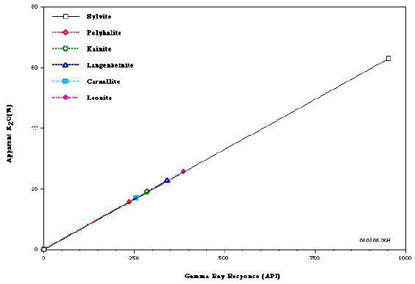
Figure 3. Linear Relationship between Potash Mineral Matrix API Response and Assigned %K₂O (after: Hill, 2019).
With this in mind, a Geologist with a SE NM mining company developed an empirical relationship of based upon seven SE NM wells with McNutt Member core assays and modern GR API unit logs, to develop a LSQ core based %K₂O transform. A review by Petrophysicist with extensive potash experience suggested that a reduced major axis (RMA) model, such as that in Figure 4, which distributes the fitting errors equally between both variables, be used instead of the LSQ Regression Model, which places all fitting errors on the dependent variable. The rationale for this change is that for petrophysical data, such as this, neither variable data can be considered to be noise-free. A second review, by an experienced mining geophysicist, echoed these comments and added that the model be based on grade-thickness, as is done for uranium evaluation.
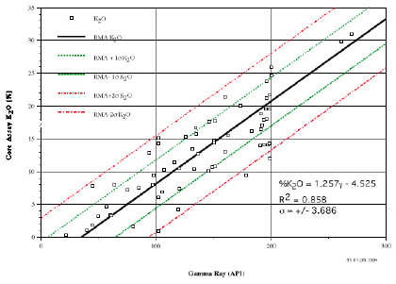
Figure 4. RMA GR to %K₂O Relationship from 7 SE NM Well cores and GR Logs (after: Hill, 2019).

Evaluation of the RMA Model
To evaluate the SE NM GR to %K₂O transform a corehole was drilled and logged, 200 ft, from a cased well, with modern API GR logs and a potash evaluation using the resulting GR transform. The resulting core was evaluated and wet chemistry assays conducted on the recovered core. Figure 5 shows the correlated GR & neutron logs between the well, on the left and the corehole, on the right. The correlation between various beds in the two is excellent, as it should be for a stratiform evaporite deposited.
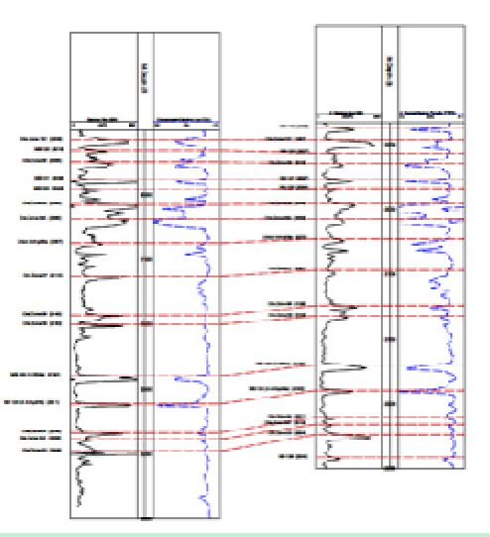
Figure 5. RMA GR to %K₂O Transform Evaluation: Cased well on Left & Corehole on Right (after: Hill, 2019).
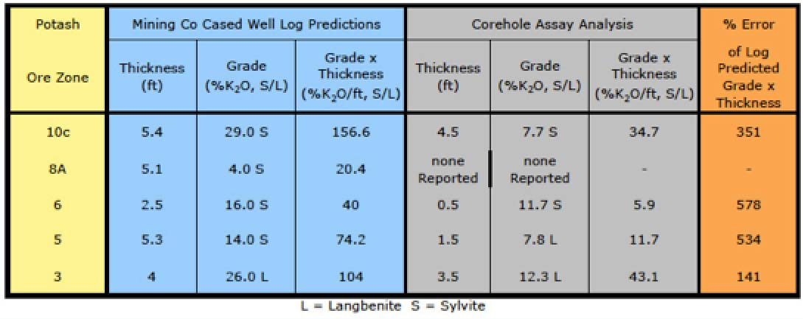
Table 2. SE New Mexico McNutt Member, RMA GR to %K₂O Model Validation Test Results (after Hill, 2919).
Table 2 summarizes the results of this validation test. Obviously, more than GR alone is needed for a McNutt Member evaporate potash screening tool.

The Wet Chemistry Core analysis of the validation core (Table 2) did not measure up to the predictions of the SE NM GR to %K₂O transform from the adjacent oil well. The obvious question is why?

Alternatives to the RMA GR Transform

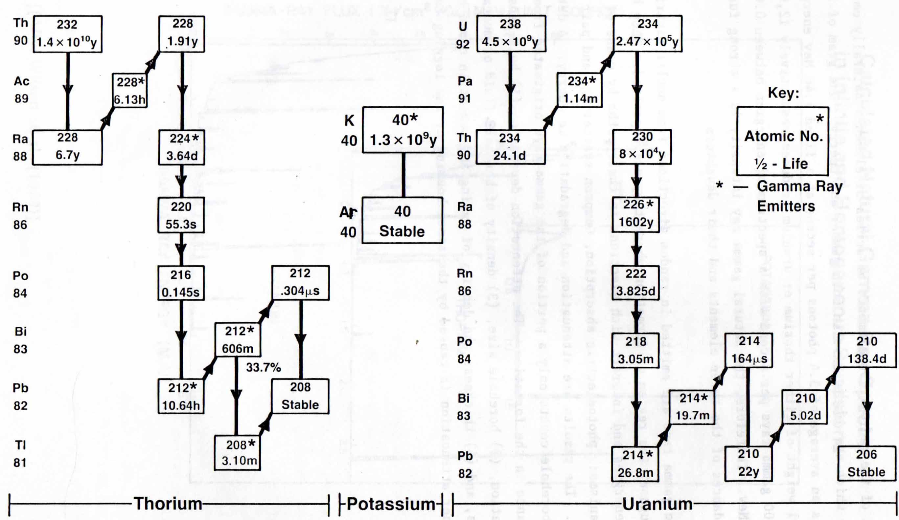
Figure 6. Potassium, Uranium, and Thorium, KUT, decay series (after: Guo, 1982).

Non Potash Radioactive Sources
First of all, potassium is not the only naturally occurring radioactive element, in the earth’s crust. Figure 6 shows the radioactive decays for the three naturally occurring radioactive elements, ⁴⁰K, ²³⁸U, and ²³²Th. While the ⁴⁰K to ⁴⁰Ar decay is direct, both ²³⁸U and ²³²Th decay through a series of radioactive daughter products before reaching a stable Pb, isotope.
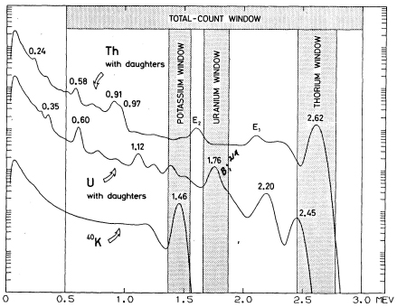
Figure 6a. Gamma Ray Count Energy Windows for Total Count and K-U-T Spectral GR Windows (after: Guo, 1982).
Common WL GR sondes measure the total decay counts over a large energy window, as shown in Figure 6. The SE NM claystones and marker beds, contain clay minerals, which often contain trace uranium and/or thorium, as well as potassium, raising the possibility of all three types of radioactive elements being present to contaminate the GR to potash transform. Special K-U-T spectral GR sondes attempt to separate the effects of the higher energy decays of the ²³⁸U, and ²³²Th decay series from that of the single ⁴⁰K to ⁴⁰Ar decay. Because daughter product decays of both the 238U, and ²³²Th series also occur within the “Potash” window, these effects must be removed to get the true potassium signal. This is done, either by Stripping or Kalman Filters (Fertl, 1979 and Mathis, et. al., 1984).
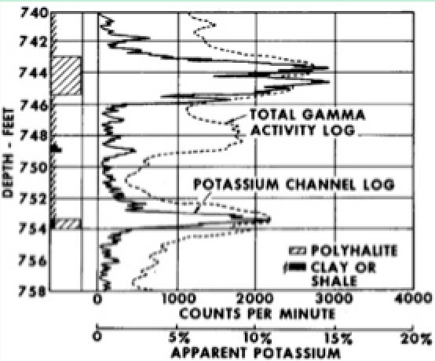
Figure 7. SE NM Total Count and K Channel GR Response Example (after: Fertl, 1979).
Figure 7 shows an example from SE NM, with both the total count and potassium channel of a K-U-T spectral GR sondes. While a K-U-T spectral gamma ray sonde might eliminate marker beds and claystones, it would not eliminate the non-commercial Potash minerals, or potassium clays.
Crain and Anderson (1966) used gamma ray, neutron and sonic logs, with linear programming, to successfully discriminate between sylvite and carnallite, in the prairie evaporites of Saskatchewan. Hill (1993) used gamma ray, density, neutron, and sonic logs, with Multi Mineral Analysis for the Winsor Evaporate, of Cape Breton Island. However, the only well logs available for most SE NM oil and gas wells will be cased hole GR and neutron.
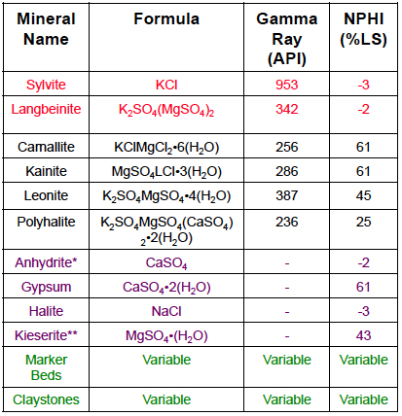
Table 3. SE New Mexico McNutt Member, Salado Formation Chemistry, Gamma ray, and Neutron Responses (after Hill, 2919).

Table 3 compares the Gamma ray and neutron responses for the most common minerals and rocks in the McNutt Member of the Salado Formation, in SE New Mexico. The obvious difference between sylvite and langbenite, which are commercial for underground mining, and carnallite, kainite, leonite and polyhalite, which are not, is that the first two are anhydrous, while the other four are hydrated. The neutron porosity log really responds to hydrogen ions, in the adjacent wall rock, which makes it a good second discriminator.

The Potash Identification (PID) Plot
Dewan and Greenwood (1955) may have been the first to recognize the utility of using both GR and neutron logs to identify potential economic potash deposits. Interestingly enough, they were considering this for SE NM. Alger and Crain (1965) showed a prairie evaporite log suite, which contained both GR and neutron logs, along with sonic and density, but did not go into any detail. Crain and Anderson used GR, neutron, and sonic logs, with linear programming to estimate sylvite, carnallite, and insolubles for prairie evaporites. Tixier and Alger (1967) pointed out that using neutron logs could eliminate carnallite, because it is hydrated. However they did not go much beyond this statement and suggesting that GR neutron, density, and sonic all be used in a joint interpretation. All of these authors were using early (including GNT neutron) second generation logging measurements. Hill (1993) used modern GR, density, neutron, and sonic logs, with multi-mineral analysis to estimate sylvite, halite, anhydrite, carnallite, and Insolubles, for the Windsor evaporites, of Cape Breton Island. Unfortunately, the only logs available from most SE NM oil and gas well are cased-hole GR and neutron, which eliminates the more sophisticated analyses.
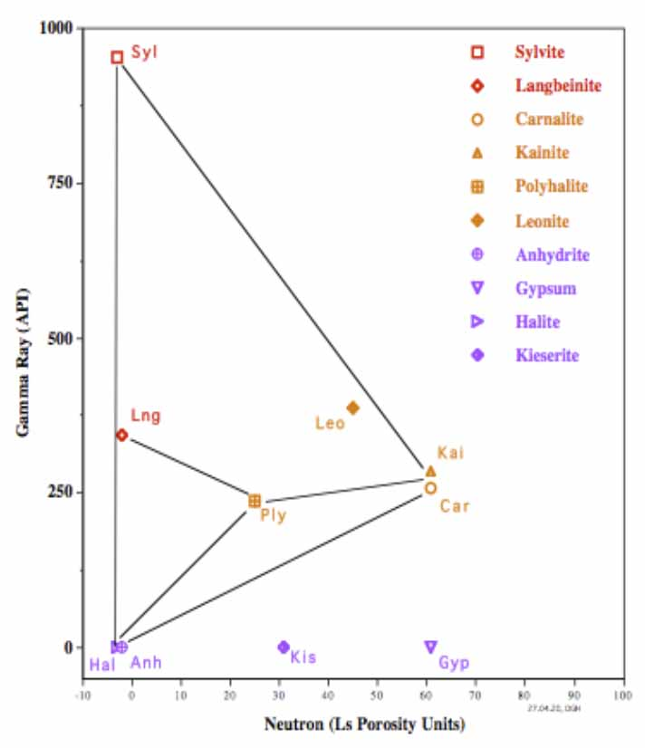
Figure 8. SE NM Potash Identification (PID) Plot Master
With insight gained from the information in Table 3, a simple graphic, the Potash Identification (PID) plot was designed, for GR and neutron data, which can be used with either digital data or hand-picked points from the printed field, or processed, log prints. Figure 8 shows the PID Master for SE NM, which shows all 6 SE NM potash minerals, as well as the 4 SE NM non-potash evaporites. The only processing required is environmental corrections.

PID Plot Validation
With the PID Plot defined, it was validated, using wells from four North American Potash locations.
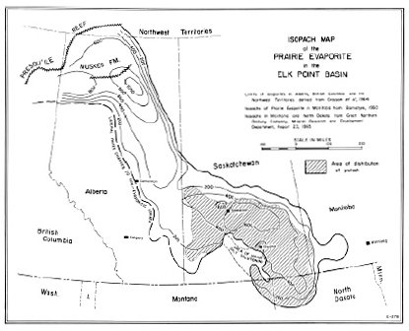
Figure 9. Prairie Evaporite (after Holter, 1969)

Prairie Evaporite, Saskatchewan
The prairie evaporites, of Saskatchewan, discovered in during the 1940’s and continuously produced, since 1962, could easily be dubbed “The Saudi Arabia of Potash”. The geology and mineralogy is quite simple:
- Simple structure and mineralogy.
- Distinct sylvite and carnallite intercepts with only minor dolomite and claystone stringers.
- Massive (up to 15m thick) beds.
- High grade (up to over 50%) sylvite.
- Uniform (can correlate over several miles, using seismic reflection).
- Extensive (covers roughly the SE quarter of the province of Saskatchewan, see Figure 9).
At the time of the current study, the Prairie #vaporite was supplying roughly 25 – 30% of the world’s potash demand and 70% of the US demand, with sufficient reserves to do so, for several hundred years.
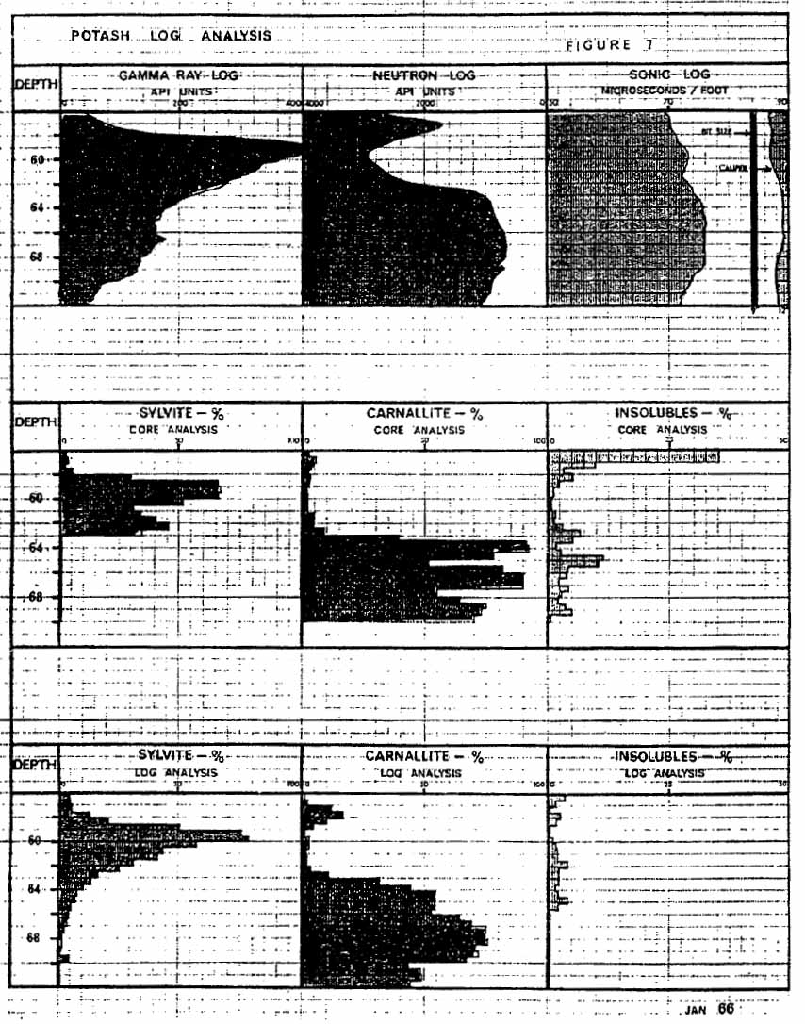
Figure 10. Prairie Evaporite Well Logs, Core Assays, and Linear Programming Log Assays (after Crain and Anderson, 1966)
Figure 10, from Crain and Anderson (1966) is one of the earliest linear programming attempts to estimate Potash assays from wireline measurements, which used the then GR, GNT, and sonic logs available. Crain (2014) further described the steps needed to accomplish this with older wireline measurements.

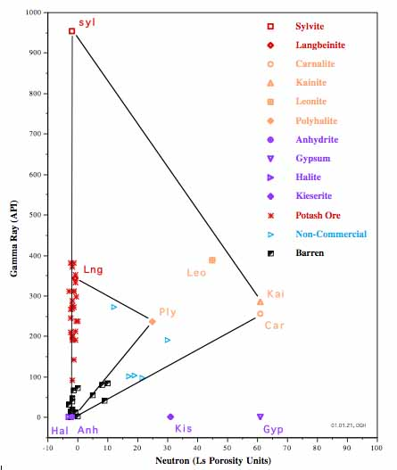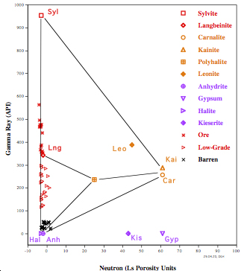

Figure 11. PID Displays for Two Prairie Evaporite Wells (after Hill and Crain, 2020).
Figure 11 shows PID displays from two Prairie Evaporite wells. The one on the right is from a section that is high-grade sylvite, with all points plotting on the PID sylvite - anhydrite/halite line. The one on the left is from a well with lower grade sylvite, and some carnallite. The PID separates the sylvite from the carnallite nicely.

Windsor Evaporite, Cape Breton Island
A minor high-grade Potash deposit, in a complex structural setting, was discovered in the Windsor evaporite of Cape Breton, Island, Nova Scotia (see Figure 12). The mineralogy is essentially sylvite, with little contamination by carnallite, associated with halite, and minor amounts of Gypsum and anhydrite.
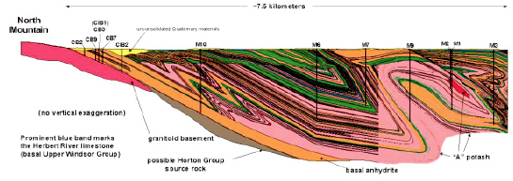
Figure 12. Cape Breton Island Structural cross section showing the Windsor Evaporite Potash Deposit (after Anon., 2007).
The mineralogy is essentially sylvite, with little contamination by carnallite, associated with halite, and minor amounts of Gypsum and anhydrite. Hill (1993) conducted multi-mineral analysis, using modern GR, CNT neutron, FDC density, and BHC sonic. Figure 13 compares the core wet chemistry analysis (left) to the multi-mineral analysis (right). The results are very good.

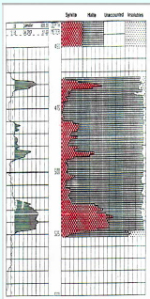
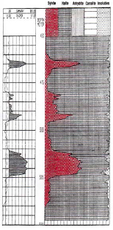

Figure 13. Cape Breton Island Well Core Assay, on Left, and Multi-Mineral Assay, on Right (after Hill, 1993).
The mineralogy is essentially sylvite, with little contamination by carnallite, associated with halite, and minor amounts of gypsum and anhydrite. Hill (1993) conducted multi-mineral analysis, using modern GR, CNT neutron, FDC density, and BHC sonic. Figure 13 compares the core wet chemistry analysis (left) to the multi-mineral analysis (right). The results are very good.
.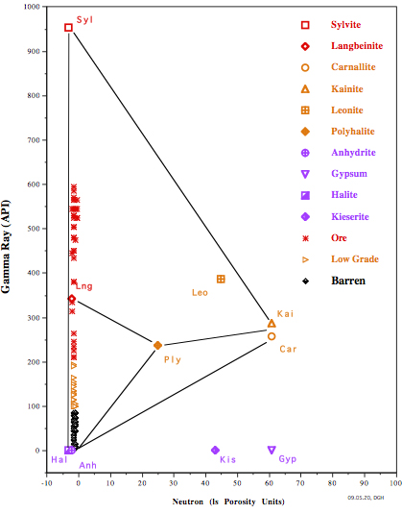
Figure 14. Cape Breton Island Well PID Display (after Hill, 2019).
While there was little, if any carnallite in this well, the PID plot shows all points (both hi-grade and lower grade sylvite) plotting on the sylvite – anhydrite/halite line, as they should.

Salina A-1 Evaporite, Michigan Basin
The Paleozoic geology of the Lower Peninsula, of Michigan is much like a “Stack of Bowls”, sitting on the Precambrian basement. Deep potash salts were discovered in the Salina A-1 evaporite of the Michigan Basin (see Figure 15) when wells drilled with saturated NaCl brines washed out. Subsequently at least one solution mining project was developed, near the township of Hershey, in NW Lower Peninsula of Michigan.
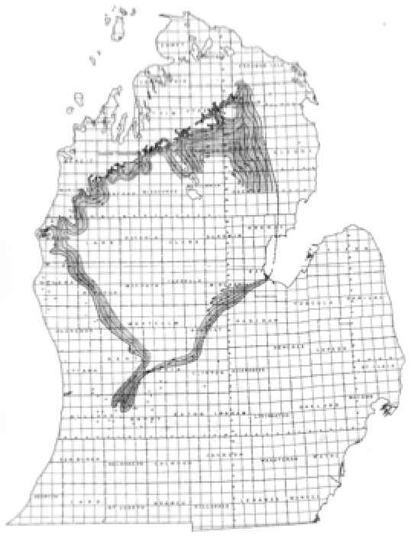
Figure 15. Michigan Basin Salina A-1 Evaporite Extent (after Hill, 2019).

. 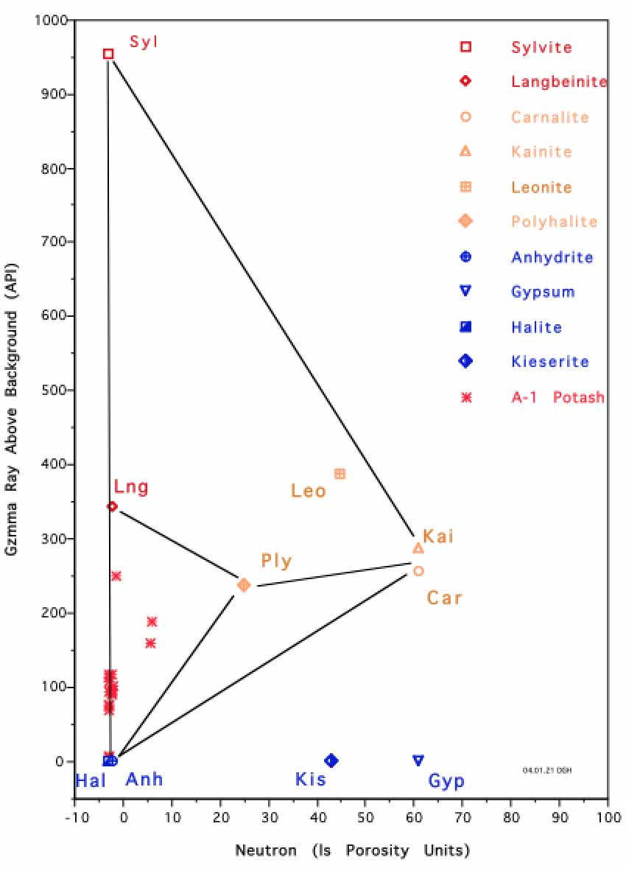
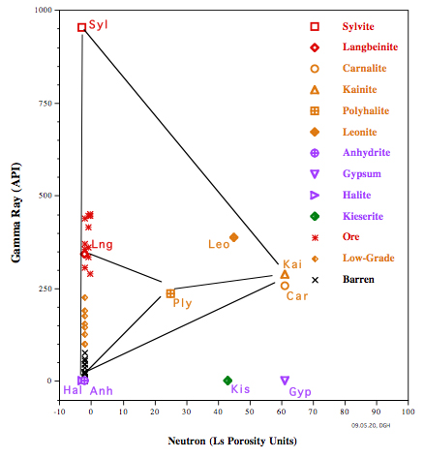

Figure 16. Michigan Basin Well PID Displays (after Hill, 2019).

Figure 16 shows PID displays for two Deep Michigan Basin Salina A-1 evaporite wells. The well on the left may have either low grade carnallite or Shales. The one on the right appears to have only low-grade sylvite.

McNutt Potash Member of the Salado Formation, SE New Mexico
The AEC condemnation of a 36 mi square area in the SE NM Potash Enclave, for the Waste Isolation Project for deposition of radioactive waste, resulted in a coring and assay campaign to determine the value of the condemned land for settlement with the then current minerals holders. The resulting public domain data offered an excellent option to evaluate the PID, for SE New Mexico.
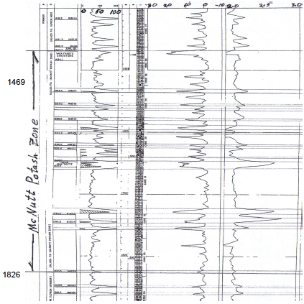
Figure 17. AEC-8 McNutt Member, Salado Formation, SE NM, Log & Lithology (After; Griswold, 1982).
Figure 17 Shows the AEC-8 McNutt Member Stratigraphy, GR, Core Graphic, neutron, and density logs for the AEC-8 Evaluation Corehole, drilled to evaluate the WIPP acreage. The Salado Formation has 49 “Marker Beds”, which can be correlated regionally across the SE NM Basin, containing the Potash Enclave. Many of these non-potash markers have ≥ 189 API units, which are comparable to, or greater than the 11 potash zones. All of the potash zones in AEC-8 are less than 8 ft thick.
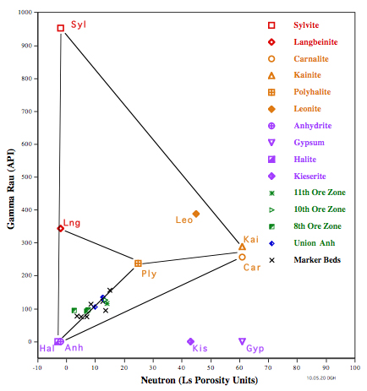
Figure 18. AEC-8 McNutt Member, Salado Formation, SE NM, Log & Lithology (After; Griswold, 1982).

Figure 18 Shows the AEC-8 McNutt Member PID. The cross-plot data all fall along the line connecting the anhydrite/halite and polyhalite mineral points, well away from the sylvite-Anhydrate/halite line. Review of the Griswold (1982) report indicates that the most commonly identified potash mineral identified in recovered cores from the AEC coring program was polyhalite.

. 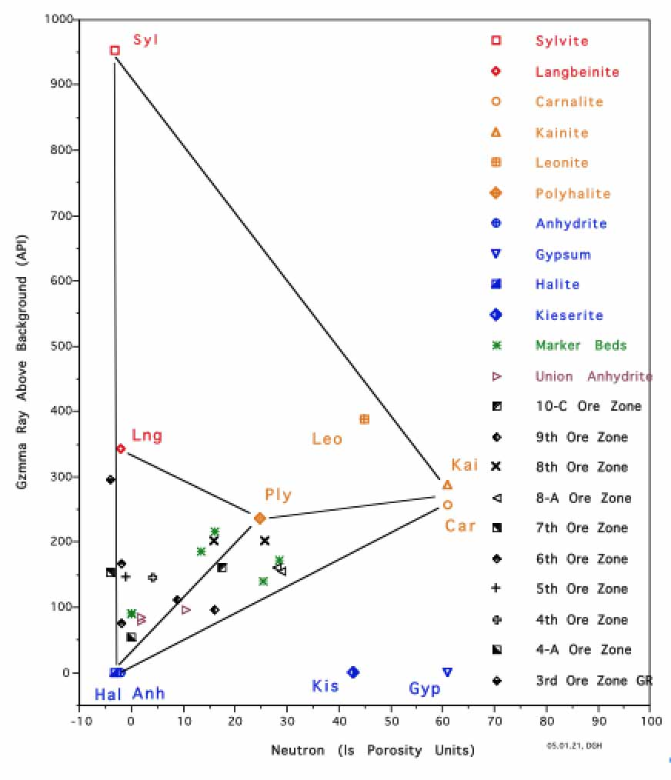
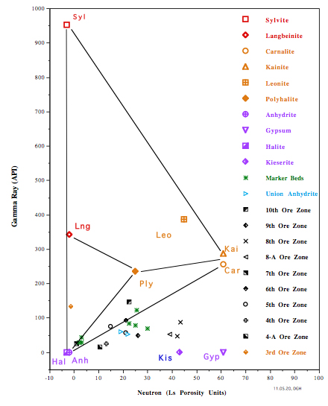

Figure 19. Validation Test PID (Corehole on Left, Oil Well on Right) McNutt Member Salado Formation.

Validation Test Oil Well and Corehole McNutt PID
With this background, we can now look at the PID, from the GR Transforms Validation Test (Figure 19). The oil well (on the left) was drilled with air, through the evaporite, cased and cemented, without logs, prior to drilling to TD. The GR and neutron logs were, run as part of the TD log suite and, thus, cased-hole logs. The project Geologist claimed that the vendor was instructed to do cased hole environmental corrections, In the Cab, which can be done with modern systems; a claim which was collaborated via a telephone call to the Roswell wireline vendor Station Manager. Only one point, in this PID, plots near the sylvite-anhydrate/halite line, which may correspond to the validation test core hole assay, for the langbenite 3rd ore zone wet chemistry assay. However, the zone thickness (2.5 ft) is under the “Minimum 4 ft thickness SE NM economic standard.
The GR Transform Validation Core hole (on the right) was a slim-hole project, as most mineral coreholes are and logged with modern slim-hole wireline equipment. The increased number of peaks posted along the sylvite-anhydrate/halite line may reflect the different wireline equipment, the smaller borehole, and the lack of casing & cement. The data point plotting near 300 API, may well correspond to the 10c^{th} ore zone. While this would pass both the grade & thickness hurdles, for SE NM, it is doubtful that it would support a mine.

Conclusions
The PID plot proved to be a simple and rapid method to screen for potential low-grade commercial potash mineralization in the presence of high GR shales, and non-economic potash minerals.
References
Alger, R. P., and Crain, E. R., 1966, “Defining Evaporite Deposits with Electrical Logs”, Northern Ohio Geological Society, Secon Symposium on Salt, v. 2, pp. 116 -.130
Anon, 2007, “Malagawatch Salt Deposit Stratigraphy and Structure”, TGI South-Central Cape Breton Island, Mineral Resources Branch, Department of Natural Resources, Province of Nova Scotia.
Anon, 2020, “Potassium-Argon Dating”, Britannica, Website.
Barker, J. M., and Austin, G. S., 1993, “Overview of the Carlsbad Mining District, New Mexico”, New Mexico Bureau of Mines and Mineral Services, Circular 207.
Barker, J., and Gundiler, I., 2008, “New Mexico Potash – Past, Present, and Future”, New Mexico Earth Matters, vol. 8 No. 2, Summer
Bogle, M. L., 2007, “Potash Enclave Standards”, Personal Communication.
Crain, E. R., 2014 “Potash Redux”, Canadian Well Logging Society, v. ??, No. ??, pp. 17 – 26.
Crain, E. R., and Anderson, W. B., 1966, “Quantitative Log Evaluation of the Prairie Evaporite Formation in Saskatchewan” Petroleum Society of the CIM, 17th Annual Technical Meeting.
Costello, J. T. and Norquay, I. P., 1969, “Logging the Prairie Evaporite Formation in Saskatchewan”, Canadian Centenmial Conference On Mining and Groundwater Geophysics
Dewan, J. T., and Greenwood, H. M., 1955, “Calibration of Gamma Ray Neutron Equipment for Identification and Evaluation of Potash Deposits”, The Technical Review, v. 6, No. 6, pp. 4 – 12.
Edwards, J. M., Ottinger, N. H., and Haskell, R. E., 1967, “Nuclear Evaluation of Potash Deposits”, SPWLA Transactions, v. 8, paper L.
Fertl, W. H., 1979, “Gamma Spectral Data Assists in Complex Formation Evaluation”, The Log Analyst, Vol 20, No. 5. pp. 3 – 37.
Giles, P., 2014, “Stratigraphy and Structure of the Malagawatch Salt Deposit, Windsor Group, Central Cape Breton Island, Nova Scotia” Natural Resources, Canada.
Griswold, G. B., 1982, “Geology Overview of the Carlsbad Potash Mining District”, New Mexico Bureau of Mines and Mineral Resources, Circular 182, pp 17-21.
Griswold, G. B., ed., 1977, “Chemical Analyses of Potash Bearing Horizons from 21 Exploratory Holes Drilled at a Tentative Site for the Waste Isolation Pilot Plant, Eddy County, NM”, Sandia National Laboratory, SAND77-1217.
Hill, D. G., 1993, “Multiple Log Potash Assay”, Journal of Applied Geophysics
Hill, D. G., 2007, “Use and Abuse of Wireline Measurements for Potash Exploration and Reserves Estimates” Briefing: Sandia National Laboratory, US Bureau of Land Management, New Mexico Oil and Conservation Division.
Hill, D. G. 2019, “Using the Potash Identification (PID) Plot to Distinguish Commercial Potash Mineralization”, ACE2019, AAPG, Denver.
Hill, D. G., and Crain, E. R., 2020, “Rapid Determination of Potash Mineralization Using Cross-Plots”, GEOConvention 2020, Calgary.
Holter, 1969, “The Middle Devonian Prairie Evaporite of Saskatchewan”, Report No. 123, Saskatchewan Department of Mineral Resources.
Mathis, G. L., Tittle, C. W., Rutledge, D. R., Mayer, R., and Ferguson, W. E., 1984, A Spectral Gamma Ray (SGRTM) Tool”, SPWLA 24thAnnual Logging Symposium.
Nelson, P. H., 2007, “Evaluation of Potash Grade with Gamma-Ray Logs”, USGS, OF Rpt. 2007-1292.
Serra, O., Baldwin, J., and Quirein, J., 1980, “Theory, Interpretation, and Practical Applications of Gamma Ray Spectroscopy, SPWLA Trans., Vol 21, Paper Q.
Tixier, M. P., and Alger, R. P., 1967, Log Evaluation of Non-Metallic Mineral Deposits”, SPWLA Transactions, V. 8

