UNICORNS IN THE GARDEN OF GOOD AND EVIL
PART 6 – BITUMEN BEARING OIL SaNDS
E. R. (Ross) Crain, P.Eng.
Spectrum 2000 Mindware Ltd
Published in CSPG Reservoir, Apr 2011
Author’s Note: The phrase “Oil Sand” has become the politically-correct term for “Tar Sands”. The old term has been replaced for this electronic version. ERC Jan 2021.
Unicorns are beautiful, mythical beasts, much sought after by us mere mortals. The same is true for petrophysical models for unconventional reservoirs. This is the sixth in a series of review articles outlining the simple beauty of some practical methods for log analysis of the unusual.
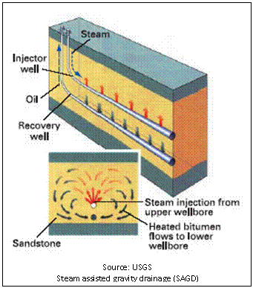
OIL SAND BASICS
Oil sands (tar sands, bitumen sands) are mined or depleted by steam assisted gravity drainage (SAGD) or in-situ fire floods. In all these situations an adequate reservoir description is needed to assess the economics and progress of any project.
A conventional shaly sand analysis using the complex lithology porosity models is the foundation for the work. A shaly sand water saturation equation, such as the Simandoux model, is also needed.
Figure 1: Schematic diagram of steam assisted gravity drainage (SAGD) in oil sands ➔
The best oil sands are clean, medium to coarse grained, unconsolidated sands. However, they may be interbedded with finer, siltier, and shalier sands or overlain by lower quality reservoir rock. The log analysis needs to describe their variations, especially laterally continuous barriers to vertical flow of steam and oil movement.
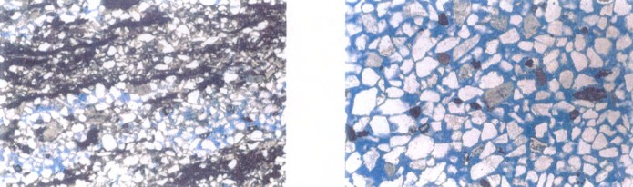Figure 2: Oil sands at 63 times magnification: shaly sand (left) with Vsh > 35%, clean sand (right) with Vsh < 5%.
The fluid column can be more complicated than conventional reservoirs. Here are some possibilities:
1. bitumen with or without bottom water
2. top water over bitumen with or without bottom water
3. gas over bitumen with or without bottom water
4. gas over top water over bitumen with or without bottom water
5. any of the above with mid-zone gas, distributed unevenly in the main bitumen zone.
Since these sands are often shallow, the gas crossover on the density neutron log is quite large and can be used as a measure of the reservoir volume filled with gas. Comparison to (1 - Sw) gives the residual bitumen volume in the gassy zones.
Tar in carbonates is also extractable with SAGD, fire floods, or solvent floods. Gas is usually less of an issue because there is less likelihood of biogenic gas generation, but gas caps may exist in some plays.
OIL SAND MATH
Tar assay data from core analysis is often presented in terms of mass (weight) fraction (or percent) and sometimes also as volumes. Log analysis results are usually in volume fractions. Comparison between log and core results needs some extra math compared to conventional oil and gas evaluations. Further, net pay is often determined by a tar mass fraction cutoff instead of porosity and water saturation.
GAS EFFECT
First let’s look at the gas problem. If there is no gas crossover, you can skip this section. The conventional equation for porosity in a gas sand is:
1: PHIe = ((PHInc^2 + PHIdc^2) / 2) ^ (1 / 2)
This equation is accurate enough for most gas zones, but in very shallow gas sands, it will underestimate porosity. The above equation must be replaced by:
2: PHIe = ((PHInc^X + PHIdc^X) / 2) ^ (1 / X)
Where:
X is in the range of 2.0 to 4.0, default = 3.0 for very shallow gas, 2.0 for conventional gas.
PHIdc and PHInc are shale corrected values of density and neutron porosity respectively.
The exponent X is adjusted by trial and error until a good match to core porosity is obtained.
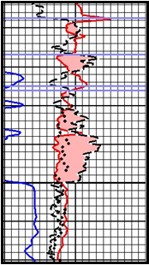
Figure 3: Large gas crossover (shaded area) in a tar sand. Note that core porosity (black dots) are close to density log porosity, suggesting that conventional equations for gas corrections may not work well. Only a few tar sands have this problem. Porosity scale is 0.60 to 0.0 left to right. ➔
PARTITIONING GAS and TAR VOLUMES
After shale volume and porosity have been calculated, water resistivity can be found in a bottom water zone below the tar, as these rarely has any residual tar. RW may vary somewhat in the tar sand interval and this can be adjusted if necessary by comparing calculated tar mass with core tar mass in non-gassy, relatively shale-free, intervals. Water saturation is then calculated from a shale corrected model such as Simandoux.
Many, but not all, gas zones related to oil sands have some residual tar. Hydrocarbon saturation is partitioned between bitumen and gas by the following method:
3: Vwtr = PHIe * Sw
4: Vhyd = PHIe * (1 – Sw)
5: GasOilRatio = Max(0, Min((1 – OILmin), (PHIDc – PHINc) / MAX_XOVER))
6: Vgas = GasOilRatio * Vhyd
7: Voil = (1 – GasOilRatio) * Vhyd
Where:
OILmin = minimum oil volume in gas zone as seen on core analysis, could be zero.
MAX_XOVER = maximum density neutron crossover in a gas zone (fractional)
OIL MASS FROM LOG ANALYSIS VOLUMETRICS
Oil weight is calculated from log analysis as follows:
8: WToil = Voil * DENSHY
9: WTshl = Vsh * DENSSH
10: WTsnd = (1 - Vsh - PHIe) * DENSMA
11: WTwtr = BVwtr * DENSW
12: WTrock = WToil + WTshl + WTsnd + WTwtr
Oil (Tar) mass fraction:
13: Woil = WToil / WTrock
14: WT%oil = 100 * Woil
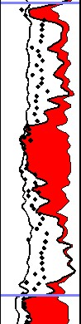
Where:
OILmin = minimum oil volume in gas zone as seen on core analysis, could be zero.
MAX_XOVER = maximum density neutron crossover in a gas zone (fractional)
Vxxx = volume fraction of a component
WTxxx = weight of a component (grams or Kg)
Wxxx = mass fraction of a component
WT%xxx = weight percent of a component
Typical densities are DENSMA = 2650, DENSW = DENSHY = 1000, DENSSH = 2300 kg/m3.
Figure 4: Comparison of oil mass from log analysis (solid line) with oil mass from Dean-Stark core analysis (dots) Oil mass scale is 0.30 to 0.00. Zone opposite this caption is gas with residual oil, above and below are oil with no gas. ➔
This is the only correct way to rigourously calculate Oil Mass. Other equations have been used, such as the one shown below, but are less accurate, since shale volume is not explicitly enumerated:
15: OILmassfrac = ((1.0 - Sw) * Phie * DENSoil) / (DENSrna * (1.0 - Phie))
In equation 15, DENSma is a computed result from the log analysis, and is usually wrong when gas is present. It hides the shale correction term and individual rock and fluid parameters cannot be adjusted. I strongly recommend that this "simplified" version be avoided.
It should be noted that core data is usually derived from a summation of fluids process, such as Dean-Stark method, so the porosity from core matches total porosity better than effective porosity. Ditto water saturation. That's why we use tar mass and not porosity and saturation to calibrate log analysis to core data.
Tar mass from log analysis is plotted along with tar mass calculated from core analysis data, on the depth plots to show the match between log analysis and core data results.
The match between log analysis tar mass, porosity, and saturation with corresponding core data is usually excellent except in the very shaly, non-pay, intervals, mostly because the core data provided ignores shale and its effect on net grain density. The match in zones with high gas saturation varies in quality due to the inherent inaccuracy in the gas/tar partitioning calculation on the log analysis.
DEAN-STARK CORE ANALYSIS METHOD
This method is used in poorly consolidated rocks such as tar sands and involves disaggregating the samples and weighing their constituent components. Samples are usually frozen or wrapped in plastic to preserve the contents during transport. In the lab, the still frozen cores are slabbed for photography and description, then samples are selected and weighed.
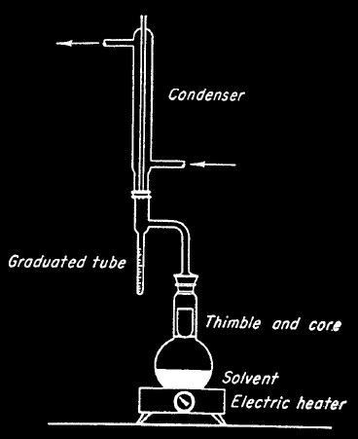
Samples are then heated and crumbled to drive off water, and weighed again. The weight loss gives the water weight. Solvents are used to remove oil or tar. The sample is weighed again and the weight loss is the weight of oil. The matrix rock is separated into clay and mineral components by flotation, dried and weighed again, giving the weight of clay and weight of the mineral grains.
16: WTwtr = WTsample - WTheated
17: WTtar = WTheated - WTminerals&clay
⬅ Figure 5: Dean-Stark laboratory apparatus
By dividing each weight by its respective density and adjusting each result for the total weight of the sample, the volume fraction of each is obtained.
18: VOLwtr = WTwtr / DENSwtr / WTsample
19: VOLtar = WTtar / DENStar / WTsample
20: PHIcore = VOLwtr + VOLtar
Assuming clay bound water is driven off by heating and drying, then PHIcore equals total porosity. From comparison to log analysis results, it appears that some clay bound water remains in many cases, so PHIcore lies between total and effective porosity from log analysis.
Figure 6: Example of Dean-Stark porosity (dots) showing that it is less than total porosity from logs (black curve) due to incomplete drying of clay. Trying to match log porosity directly to core may be futile in many cases. Comparison of tar mass is the best criteria. Porosity scale is 0.50 to 0.00. ➔
OIL (TAR) MASS FROM CORE LISTINGS
If not provided on the core listing, the equivalent value of tar mass from core analysis is derived from porosity, oil saturation, and an assumed oil density:
21: Woil = PHIcore * Soil * DENShy
22: Wwtr = PHIcore * Swtr * DENSwtr
23: Wrock = (1 – PHIcore) * GR_DENScore
Where:
Soil = oil volume relative to pore volume
Swtr = water volume relative to pore volume
PHIcore = volume of water + volume of oil
Woil = oil mass fraction
WTwtr = water mass fraction
WTrockcore = rock mass fraction
PHIcore | Soil | Swtr | Vol Oil | Vol Wtr | GR_ DEN | WT Oil | WT Sand | WT Wtr | WT Rock | Oil Mass Wtar | Wtr Mass Wwtr | Rock Mass Wrock
frac | frac | frac | frac | frac | kg/m3 |  |  |  |  | frac | frac | frac
0.306 | 0.301 | 0.699 |  |  | 2.650 | 0.092 | 1.839 | 0.212 | 2.143 | 0.043 | 0.099 | 0.858
0.271 | 0.236 | 0.764 | 0.064 | 0.207 | 2.650 | 0.064 | 1.932 | 0.207 | 2.203 | 0.029 | 0.094 | 0.877
0.279 | 0.306 | 0.694 | 0.085 | 0.194 | 2.650 | 0.085 | 1.911 | 0.193 | 2.189 | 0.039 | 0.088 | 0.873
0.244 | 0.304 | 0.696 | 0.074 | 0.170 | 2.650 | 0.074 | 2.003 | 0.168 | 2.246 | 0.033 | 0.075 | 0.892
0.298 | 0.217 | 0.783 | 0.065 | 0.233 | 2.650 | 0.065 | 1.860 | 0.233 | 2.158 | 0.030 | 0.108 | 0.862
0.273 | 0.298 | 0.702 | 0.081 | 0.192 | 2.650 | 0.081 | 1.927 | 0.191 | 2.199 | 0.037 | 0.087 | 0.876
Table 1 (above): When saturations and porosity are known (blue shading), all other terms can be calculated. GR_DENS must be measured or assumed, and DENSwtr and DENStar are usually assumed to be 1000 Kg/m3. Some core analysis reports do the math for you, some do not.
Since GR_DENScore represents a mixture of quartz and shale, this value should vary with shale volume. However shale volume is never reported on core analysis, so the composite grain density from the rock sample is used. If grain density is not recorded in the core analysis, we must assume a constant of 2650 Kg/m3 or lower.
FLUID VOLUMES FROM CORE LISTINGS
If not provided on the core listing, the equivalent value of oil volumes from core analysis are derived from porosity, oil mass fraction, and an assumed oil density:
24: Soil = Woil / (PHIcore * DENShy)
25: Swtr = Wwtr / (PHIcore * DENSwtr)
OR 26: Swtr = 1.00 - Soil
Where:
Soil = oil volume relative to pore volume
Swtr = water volume relative to pore volume
PHIcore = volume of water + valume of tar
Woil = oil mass fraction
Wwtr = water mass fraction

Soil | Swtr | Vol Oil | Vol Wtr | GR_ DEN | WT Oil | WT Sand | WT Wtr | WT Rock | Oil Mass Woil | Wtr Mass Wwtr | Rock Mass Wrock
frac | frac | frac | frac | kg/m3 |  |  |  |  | frac | frac | frac
0.301 | 0.699 | 0.092 | 0.214 | 2.650 | 0.092 | 1.839 | 0.212 | 2.143 | 0.043 | 0.099 | 0.858
0.236 | 0.764 | 0.064 | 0.207 | 2.650 | 0.064 | 1.932 | 0.207 | 2.203 | 0.029 | 0.094 | 0.877
0.306 | 0.694 | 0.085 | 0.194 | 2.650 | 0.085 | 1.911 | 0.193 | 2.189 | 0.039 | 0.088 | 0.873
0.304 | 0.696 | 0.074 | 0.170 | 2.650 | 0.074 | 2.003 | 0.168 | 2.246 | 0.033 | 0.075 | 0.892
0.217 | 0.783 | 0.065 | 0.233 | 2.650 | 0.065 | 1.860 | 0.233 | 2.158 | 0.030 | 0.108 | 0.862
0.298 | 0.702 | 0.081 | 0.192 | 2.650 | 0.081 | 1.927 | 0.191 | 2.199 | 0.037 | 0.087 | 0.876
Table 2 (above): If oil mass fraction and water mass fraction are known, as well as core porosity (blue shading), all other terms can be calculated. Some core analysis reports do the math for you, some do not.
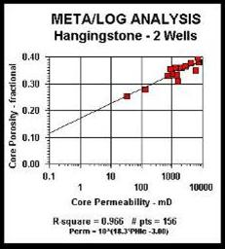
PERMEABILITY
Permeability is calculated from the following equation, based on data from the core analyses.
27: Perm = 10 ^ (HPERM * PHIe – JPERM)
Figure 7: Example graph of horizontal permeability from an oil sand ➔
Vertical permeability is especially important in SAGD operations, and similar equations can be developed by plotting core porosity against vertical permeability. Both horizontal and vertical perm can be generated from log analysis porosity and plotted versus depth. An alternate approach is to do a regression of Kv versus Kh.
OIL CUTOFFS and PAY FLAG
A bitumen pay flag is calculated with a log analysis tar mass cutoff, usually between 0.050 and 0.085 oil mass fraction. A gas flag should also be shown on the depth plots where density neutron crossover occurs on the shale corrected log data.
OIL IN PLACE
Oil in place (tonnes) is calculated from:
28: OIPwt = SUM (Woil * DENSHY * THICK) * AREA
Where:
AREA = reservoir area (m2)
THICK = rock thickness (meters)
OIPwt = oil in place (tonnes)
Woil = oil mass fraction (fractional)
DENSHY = density of bitumen (g/cc)
If the oil equivalent in barrels or cubic meters is needed, the standard equation can be used:
29: OOIP = KV3 * SUM(PHIe * Star * THICK) * AREA / Bo
Where:
KV3 = 7758 bbl for English units
KV3 = 1.0 m3 for Metric units
AREA = spacing unit or pool area (acres or square meters)
OOIP = oil in place as bitumen (bbl or m3)
Recovery factor for surface mining operations is very high, maybe 0.98 or better. For SAGD, RF = 0.35 to 0.50 are used. Since we can't keep the steam away from the shaly sands, recovery will vary with the average rock quality in a SAGD project. Since water has a very high latent heat, the volume of water to be steamed is as important to the economics as the volume of bitumen. High water saturation is bad news here, just as in conventional oil.

OIL SAND EXAMPLE 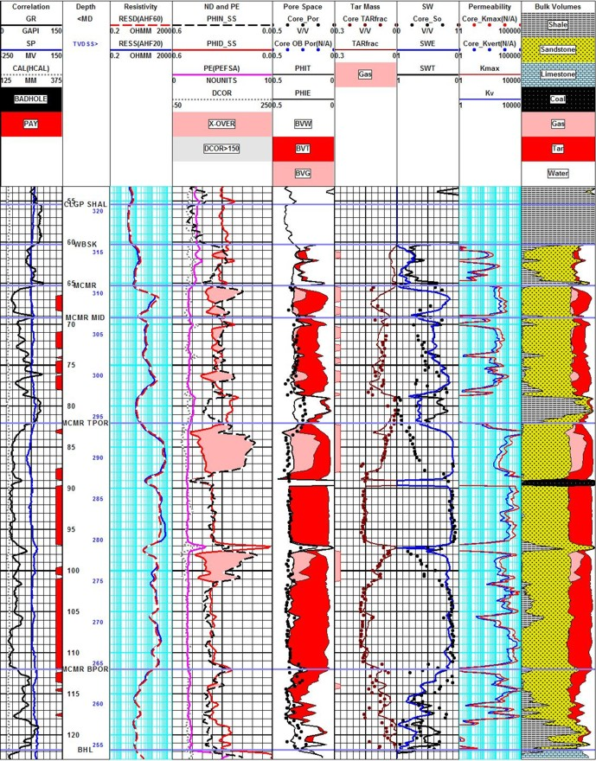
Figure 8: Tar sand analysis with top water, bottom water, top gas, and mid zone gas. Core and log data match - but tar mass is the critical measure of success. Core porosity is close to total porosity from logs, due to the nature of the summation of fluids method used in these unconsolidated sands. Minor coal streaks occur in this particular area.

